Tamagochi APP

# Introduction

In today's digital age, the integration of technology into learning has transformed the way we interact with historical information.

Apps provide a unique platform for users to explore and engage with various events, figures, and periods. This report aims to delve into the purpose of a Tamagochi app is essential when design considerations for creating a successful and engaging application.

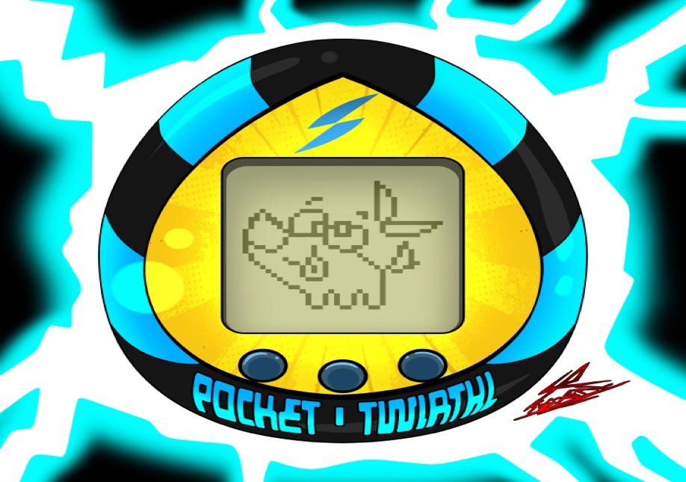

[This Photo](https://www.newgrounds.com/art/view/subrealstudios64/tamagotchi) by Unknown Author is licensed under [CC BY-NC](https://creativecommons.org/licenses/by-nc/3.0/)

First of what is Kotlin?

Kotlin is a statically typed programming language that runs on the Java Virtual Machine (JVM). It was developed by JetBrains, the company behind IntelliJ IDEA, and officially announced in 2011. Since its inception, Kotlin has gained significant traction in the software development community due to its concise syntax, interoperability with Java, and strong tooling support.

Android App Development**: Kotlin has become an officially supported language for Android development by Google. Many Android developers have embraced Kotlin due to its modern features, which can help improve productivity and code readability compared to Java. Web Development: Kotlin can be used for web development, both on the frontend and backend. Kotlin can be compiled to JavaScript using tools like Kotlin/JS, allowing developers to write frontend code in Kotlin. Additionally, Kotlin can be used with frameworks like Ktor and Spring Boot to build backend services for web applications. Data Science and Machine Learning: Kotlin’s interoperability with Java libraries makes it suitable for data science and machine learning tasks. Developers can leverage Java libraries like Deeplearning4j or Weka in Kotlin projects, allowing them to take advantage of existing Java ecosystem tools and libraries.

For this assignment , I was tasked to create a tamagochi app featuring a welcome page that leads users into the game where they can play , clean and feed their virtual pet while keeping a close eye on the pets Health

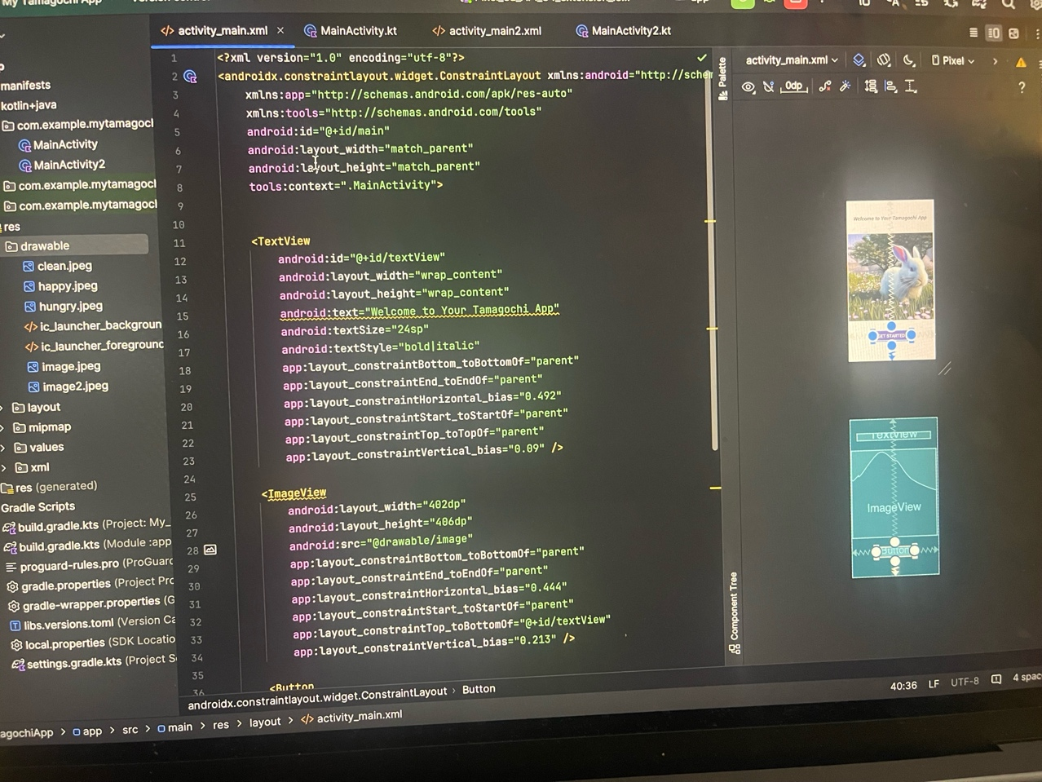

A Tamagotchi app is a digital adaptation of the classic Tamagotchi virtual pet toy that gained immense popularity in the 1990s. The original Tamagotchi was a handheld digital pet simulation game developed in Japan. It featured a small egg-shaped device with a screen where users could interact with a virtual pet, feeding it, playing with it, and taking care of its needs to ensure it stayed healthy and happy.

A Tamagotchi app essentially brings this experience to smartphones and other digital devices. Users can download the app and raise their virtual pet, nurturing it through various stages of growth and development. The app typically includes features such as feeding, playing games, cleaning up after the pet, and attending to its health needs.

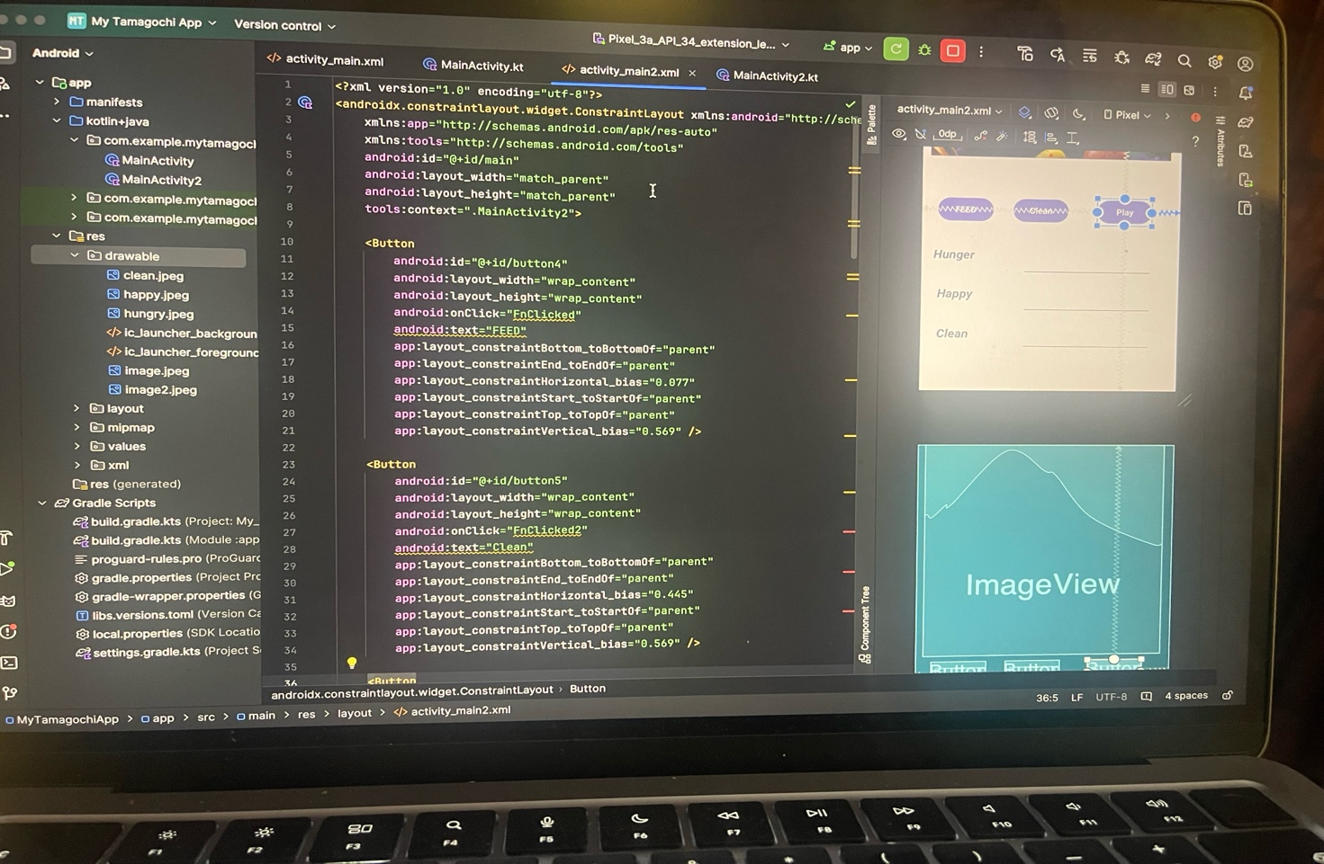

In terms of societal impact, Tamagotchi apps can serve several purposes:

1. Entertainment: They provide users with a nostalgic experience and offer entertainment and distraction, particularly for those who enjoyed the original Tamagotchi or similar virtual pet toys.
2. Stress relief: Taking care of a virtual pet can be a calming and stress-relieving activity for some people. It provides a sense of responsibility and companionship without the real-world demands of pet ownership.
3. Educational value: Tamagotchi apps can teach users about responsibility and the importance of caring for others, even if it's in a virtual context. They can also help users develop time-management skills as they need to attend to their virtual pet's needs regularly.
4. Social interaction: Some Tamagotchi apps include social features that allow users to connect with friends who are also raising virtual pets. This can foster a sense of community and shared experience among users.

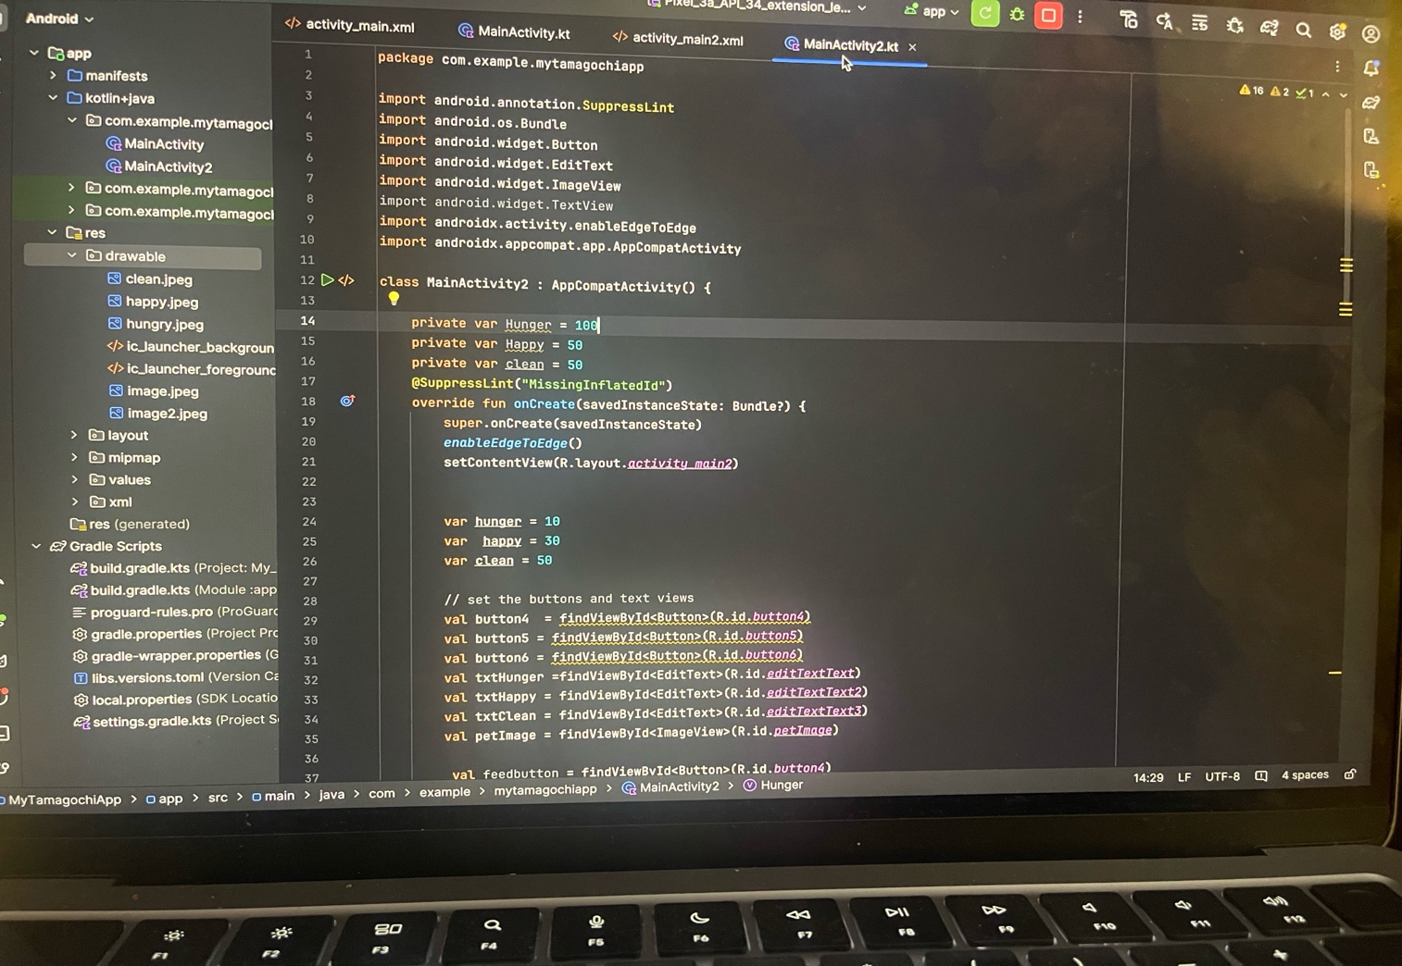

In conclusion

Ensure the app is responsive, fast, and compatible with a variety of devices and operating systems to reach a broader audience.

Implement robust security measures to protect user data, privacy, and sensitive historical information stored within the app.

Regularly update the app with new content, features, and improvements based on user feedback and emerging trends in technology and historical research.

References :

1 Brown, A 2020 . Case Study on Digital Humanities

2 Smith , J 2021 . The role of apps in education 112 – 125

3 National Museum of History2021. Case study of the history Tamagochi app

4 Pictures taken on phone , from android studios code